2026 James Mifflin Allied Trades and Continuing Education Scholarship
Submission Deadline: October 19, 2026.
Scholarship Amount: $5,000
Donor: F.H. Furr

Applicant information

Name__________________________________________________________

Address: _________________________________________________________

City: _____________________________________ Zip: ________________________

Phone: _____________________________

Email: ______________________________

Application Attachments:
- Complete Application Form and Resume.
- Personal Statement (1000-1500 words): Summarize your knowledge of the MOH and the actions that led to James Mifflin becoming a Recipient. Describe a personal challenge that required you to take positive actions to overcome adversity. Describe how you would use the award funds to pursue your goals in life.
- Two Letters of Recommendation: Submit two letters of recommendation. The letters should be from a person who can attest to your actions to overcome adversity and/or your positive representation of the MOH values. The Medal of Honor commemorates 6 key values: Courage, Commitment, Integrity, Sacrifice, Citizenship, and Patriotism.

IMPORTANT: Monumental Honor will present this grant during an event at the Valentine Museum on November TBD, 2026.

Submission Instructions
- Deadline: Applications will be accepted between August 1, 2026 and October 19, 2026 with final decision and presentation on or about November 13, 2026
  - Finalists should expect to conduct a phone interview to discuss how they plan to use the award funds in more detail
- Submission Method: All application components must be submitted electronically to
max.newcamp@monumentalhonor.org and carl.grunow@monumentalhonor.org.
  - Subject line: “James Mifflin Scholarship Application”
- File Format: Consolidate all documents into a single PDF titled “Last Name, First Name – James Mifflin Application”

For questions or additional information, please contact:

Carl Grunow
Secretary, Monumental Honor
Email: carl.grunow@monumentalhonor.org
Website: www.monumentalhonor.org

Recipient: James Mifflin

Medal of Honor Essentials (Congressional Medal of Honor Society Webpage

MOH Citation: On board the U.S.S. Brooklyn during successful attacks against Fort Morgan, rebel gunboats, and the ram Tennessee in Mobile Bay, 5 August 1864. Stationed in the immediate vicinity of the shell whips, which were twice cleared of men by bursting shells, Mifflin remained steadfast at his post and performed his duties in the powder division throughout the furious action which resulted in the surrender of the prize ram Tennessee and in the damaging and destruction of batteries at Fort Morgan.
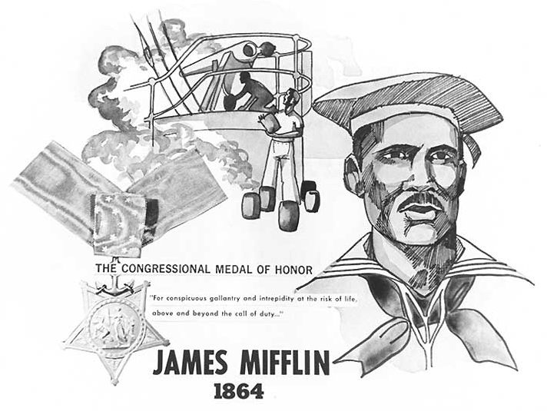
U.S. Navy poster featuring Medal of Honor recipient James Mifflin. Courtesy of the Naval History and Heritage Command # NH 103774.
- Rank: Engineer's Cook
- Conflict/Era: U.S. Civil War
- Unit/Command:
U.S.S. Brooklyn
- Military Service Branch: U.S. Navy
- Medal of Honor Action Date: August 5, 1864
- Medal of Honor Action Place: Mobile Bay, Alabama, USA
- Accredited to: Virginia
- Awarded Posthumously: No
- Born: 1839, Richmond, Virginia, US
- Died:

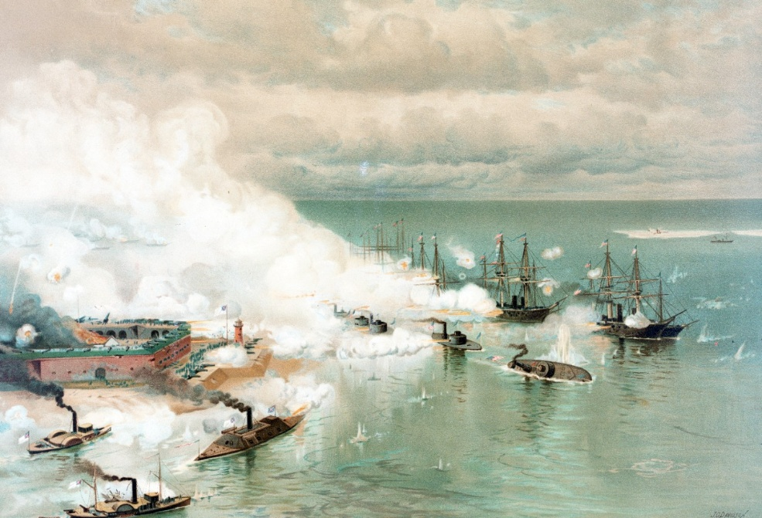
Battle of Mobile Bay, Passing Fort Morgan and the Torpedoes, August 1864.

